Bodywork by Becca
LMT8329
Client Intake Form and Health Release Form
Name:__________________________________________ Telephone(_______)______________________________Date of Birth: ___________________
Address:______________________________________________________________________________________________
Emergency contact:_______________________________________ Referred by:____________________________________
Previous massage experience:____________________________ Are you under medical supervision?_________________
Email:__________________________________________________________________________________________________________
Check all that apply:
_Bone or joint disease | _Osteoporosis | _Thrombosis | _Pinched nerve | _Reproductive Issues | _Bladder/ kidney ailment
_Tendonitis/Bursitis | _ Heart Conditions | _Breathing difficultly | _Chronic Panic | _Prostate Issues | _Colitis
_Arthritis/Gout | _ Varicose Veins | _ Allergies | _Paralysis | _Rashes | _Crohn’s Disease
_Lupus | _Blood Clots | _Sinus Problems | _Multiple Sclerosis | _Athletes foot | _ Ulcers
_Spinal Problems | _High/ Low Blood Pressure | _Shingles | _ Parkinson’s | _ Herpes | _Anxiety/ Stress
_Migraines/Headaches | _ Lymphedema | _Numbness/ Tingling | _ Pregnant  Stage _____ | _Irritable Bowel Syndrome | _ Depression
_Cancer | _ Diabetes | _ Drug/ Alcohol/ Tobacco Use | _ Contact Lenses | _Dentures | _ Hearing Aids
Please explain any chronic conditions that you have marked above or any condition not listed ______________________________________________________________________________________________________________________________________________________________________________________________________________
Please provide a brief history on any muscular, bone, or nerve injuries:
______________________________________________________________________________________________________________________________________________________________________________________________________________
Preferred massage pressure:
○Light ○Medium ○Deep
What do you hope to accomplish with today’s session? _______________________________________________________________________________________________________
Areas of stress or pain:
Please select the pain scale for each area 0 being no pain 10 being unbearable
Neck:  0 1 2 3 4 5 6 7 8 9 10 | Back:  0 1 2 3 4 5 6 7 8 9 10 | Shoulders:  0 1 2 3 4 5 6 7 8 9 10
Legs:  0 1 2 3 4 5 6 7 8 9 10 | Arms:  0 1 2 3 4 5 6 7 8 9 10 | Other:  0 1 2 3 4 5 6 7 8 9 10

Are you comfortable with these regions being massaged?
Scalp: Y or N | Face: Y or N
Pectoral Muscles: Y or N | Glutes: Y or N
Feet: Y or N | Abdomen: Y or N

Please indicate where your main focus for massage would be:
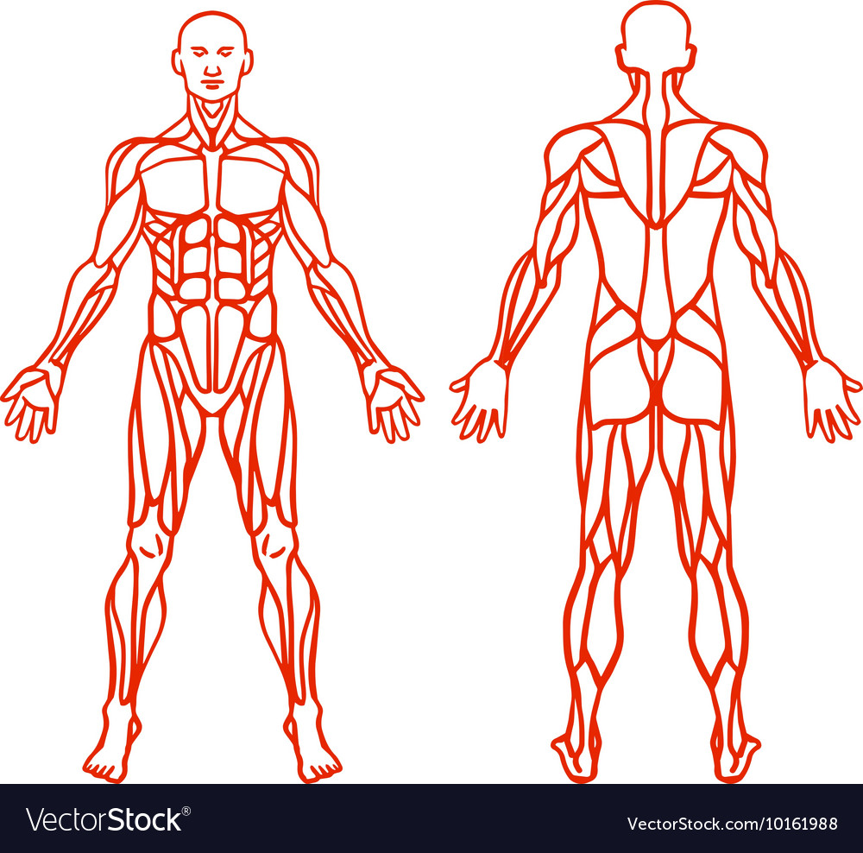

Are there any areas you would like to avoid in today’s session? ____________________________________________________________________________________________________
It is your responsibility to inform the therapist of any pre-existing conditions, limitations, or specific sensitives and to inform your therapist if you feel any discomfort during the session. Proper draping is required throughout the entire session. If at any time you feels uncomfortable you agree to end the session or communicate your discomfort to the therapist so adjustments can be made to either draping, pressure, heat, technique, or if possible environment. The therapist can refuse or discontinue if such service is deemed unsafe or if the client engages in any inappropriate behavior. Illegal or indecent behavior will not be tolerated in any manner. The therapist may in her sole discretion, end the session, charge full value price for the service, ban the client from further bookings, and notify proper authorities if you engage in illegal or indecent behaviors. By signing below you are aware of the benefits and risks of massage and hereby release Bodywork by Becca (including all practitioners and employees) from all liability for any injury including without limitation, personal, bodily, or mental injury, economic loss, any damage to you or your residence resulting therefrom. You also hereby release all the forgoing personnel and entities from all liability from any such injury or damage resulting from failure to disclose pre-existing conditions, limitation, or discomfort during your service. . I understand that massage is designed for the purpose of relaxation and relief from tension, muscle spasm, or poor circulation. The massage therapist cannot diagnose medical issues/ diseases/ disorders or preform spine palpitations. The undersigned acknowledges that he/she has read this agreement and gives their consent to treat.
Signature: ____________________________________________ Date:_____________

